# **CEA System - Functional Requirements**

## 

## **Creation of Projects**

The finance department, at the beginning of the fiscal year, will upload all the approved CEA / MRE budgets into the system; conforming to the format (MS Excel sheet) defined by ICT department.

The information in the Excel sheet contains the following fields and its description:

|  |  |  |
| --- | --- | --- |
| Field Name | Data Type | Description |
| Fiscal Year | Small Int | Financial year |
| Expenditure Type | Varchar(10) | Available options:   * CEA * MRE * INC |
| Cost Center | Varchar(12) | Refers to the department code |
| Project Number | Varchar(12) | Unique project reference number |
| Expense Category | Varchar(15) | Available options:   * MRE * Maintenance * Non-capital |
| Expense Description | Varchar(200) | Brief description about the project |
| Detailed Description | Varchar(2000) | Detailed and full description about the project |
| Amount | Numeric(18,3) | Project cost in BD |
| Account Code | Varchar(12) | Cost Center account code |
| Object Code | Varchar(12) | Object account code |
| Subject Code | Varchar(12) | Subject account code |
| Company Code | Small Int | Uses the following company code:   * 100 - GARMCO Main Mill * 600 – GARMCO Foil Mill |
| Project Start Date | DateTime | Expected project execution date |

Currently, there are 3 expenditure types used in the system which include the following:

1. CEA – Capital Expenditure Addition
2. MRE – Major Revenue Expenditure
3. INC - Item Non-Capitalized

The screenshot below shows the Project Inquiry form which contains the list of all projects allocated for each cost center based on fiscal year. Users will submit a CEA request by clicking the “Create” link found in the desired project number.

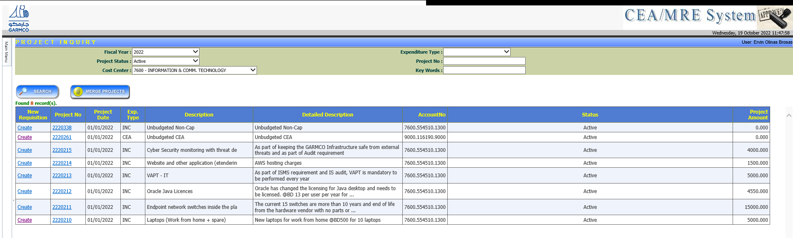

### Closure of Projects

The Finance department, at the end of the fiscal year, has the facility to close completed projects and CEA requests which can be done by opening the project details and then clicking the “**Close the Project**” button as shown in the screenshot below.

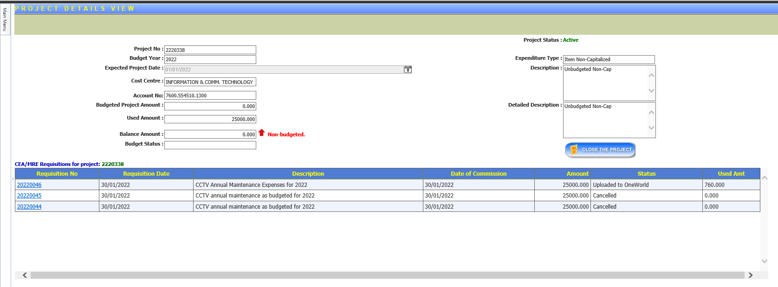

This process can also be automated by ICT by running a script to close all projects and CEA requests at once which usually requires a Helpdesk request ticket to be issued by the Finance department.

## **Expenditure Request Management**

### This function would provide a set of features to manage the expenditure request. The completed expenditure request will be uploaded into JDE ERP system.

### Creating an Expenditure Request

The initiator will create an expenditure request by entering the relevant information based on the project details. The initiator would select an Item Type when creating an expenditure request, which can be any of the following types:

* Computer Related
* Human Resources
* Civil Engineering
* Mechanical Engineering
* Electrical Engineering
* Administration
* Transportation Related
* Furnitures and Stationaries
* Medical Related
* Safety Related
* Projects
* Office Equipment
* Quality Related
* Maintenance Related

The expenditure request is mapped to an approval group. Once all information is provided, the initiator will submit the request and would then initiate the approval process. Additionally, the system will facilitate the attachment of relevant external documents to the request. External documents can be attached only by the initiator or the department managers.

The system will check the available budget for the requested project. If the budget amount is not sufficient for the request, the system will notify the initiator who created the expenditure request and the department manager.

The following workflow approval process will take place upon submission of an expenditure request.

1. The request will be assigned to the Originator for approval. *(Notes: The Originator is the person who will check the accurateness of the information given in the request and is specified by the initiator during request submission.)*
2. Once the Originator approves the request, it will undergo cost center approval which involves the following roles:
   1. Superintendent – refers to the Head of the department
   2. Cost Center Manager – refers to the Manager of the department

*(Notes: In some departments, Superintendent and Cost Center Manager role refers to the same person. In such scenario, only one approval is required.)*

1. After the cost center approval is completed, the request will go to the Executive Manager – Operations if the Originator’s cost center is any of the following:
   1. 3250 – ROLLGRINDING
   2. 5200 – MECHANICALENGINEERING
   3. 5300 – ELECTRICALENGINEERING
   4. 5400 - CENTRAL ENGINEERING

Otherwise, the request will go to the Executive Manager – Finance for approval.

1. If the request is budgeted and the amount is greater than BD 20,000, or if the request is not budgeted and the amount is greater than BD 5,000, it will go to the following roles for approval in sequential order:
   1. General Manager
   2. Chief Executive Officer
2. If the request is budgeted and the amount is greater than BD 100,000, or if the request is not budgeted and the amount is greater than BD 50,000, the request will be assigned to the Chairman for final approval.

Once the approval process is completed, the request will be set into “Approved” status. All approved CEAs will be uploaded to JDE manually by the Executive Personal Assistant. This person has the authority to view all approved CEA requisitions in the system and can post it to JDE by clicking the “Upload to JDE” button.

At each approval level, the application checks the Leave Requisition module, which is a separate system, to validate the availability of an approver. If an approver is on-leave, the workflow will automatically assign the request to the substitute if it’s defined in the leave request. Otherwise, it will be assigned to the original approver.

Below summarize the item category approvers as well as the workflow approval process:

**Item Category Approvers:**

|  |  |
| --- | --- |
| **Item Type** | **Approver Roles** |
| Administration | General Manager |
| Furniture & Stationary | General Manager |
| Maintenance Related | General Manager |
| Medical Related | General Manager |
| Office Equipment | General Manager |
| Projects | General Manager |
| Quality Related | General Manager |
| Civil Engineering | Executive Manager - Operations |
| Electrical Engineering | Executive Manager - Operations |
| Mechanical Engineering | Executive Manager - Operations |
| Computer Related | Senior Group ICT Manager |
| Human Resources | Executive Manager - Administration |
| Safety Related | Head of HSE |
| Transportation Related | Head of HSE |

**Workflow Approval Process:**

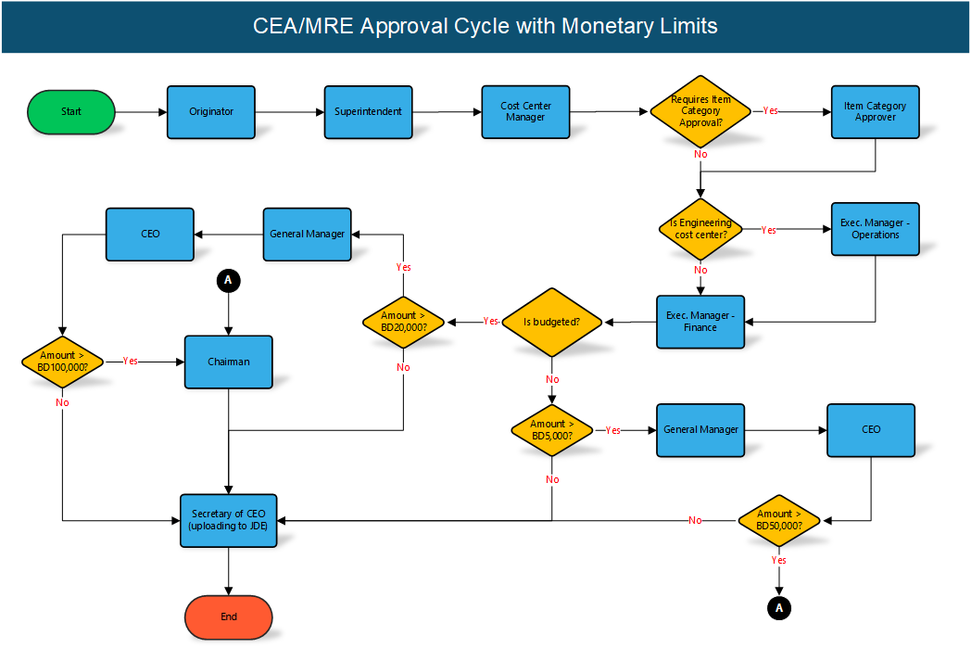

**Use Case Diagram:**

